Amazon MQ (AWS)
Amazon MQ is a fully managed message broker service provided by AWS. It allows different applications to send, store, and receive messages using standard messaging protocols.

Real-Time Example
Imagine an online shopping application.
- Customer places an order.
- Order Service sends an order message to Amazon MQ.
- Amazon MQ stores the message safely.
- Inventory Service receives the message and updates stock.
- Payment Service receives the message and processes payment.
- Shipping Service receives the message and prepares delivery.
If Inventory Service is temporarily down,
- Amazon MQ stores the message.
- When Inventory Service comes back online,
- It receives the stored message.
No data is lost.

Why Do We Need Amazon MQ?
Without MQ
Application A ---------> Application B
If Application B is unavailable,
- Communication fails.
- Data may be lost.
- Application A may crash or retry continuously.

With MQ
Application A
|
|
Amazon MQ
|
|
Application B
If Application B is unavailable,
Amazon MQ stores the message until B is available.

Amazon MQ Broker Types
Amazon MQ supports two broker engines.

1. Apache ActiveMQ
Most commonly used.
Supports
- JMS
- AMQP
- MQTT
- OpenWire
- STOMP
- WebSocket
Suitable for enterprise applications.

2. RabbitMQ
Lightweight and fast.
Supports
- AMQP
- MQTT
- STOMP
Widely used in microservices.

Below is a complete hands-on lab for Amazon MQ that you can perform in your AWS account. It also includes what you need for your implementation document.

Task 1: Create and Configure Amazon MQ Broker

Objective
Learn how to
- Create Amazon MQ Broker
- Create Users
- Connect to Broker
- Send Messages
- Receive Messages
- Monitor Broker

Architecture
Application A

│

▼

+------------------+
| Amazon MQ |
| Broker |
+------------------+

│

▼

Application B

Prerequisites
- AWS Account
- IAM User
- One VPC
- One Public Subnet (for lab simplicity)
- Security Group

Step 1: Open Amazon MQ
AWS Console
Search
Amazon MQ
Open Dashboard.

Step 2: Create Broker
Click
Create Broker
Engine
ActiveMQ
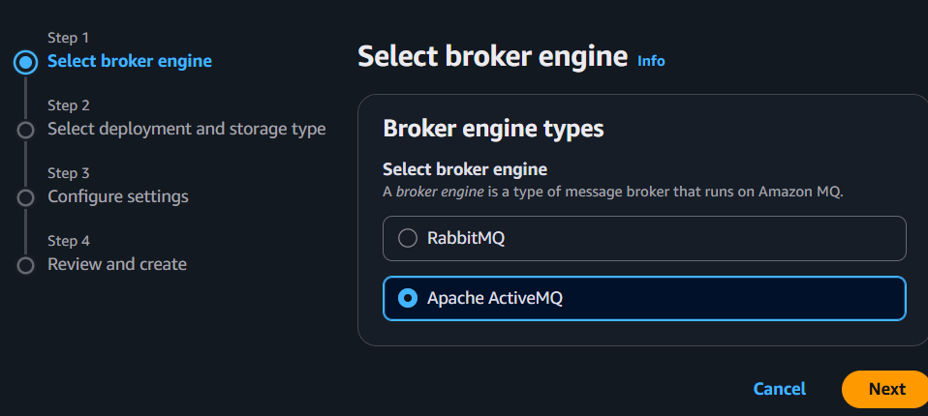
Deployment Mode
Single-instance Broker
Broker Name
DevBroker

Step 3: Configure Authentication
Username
admin
Password
Example
Admin@12345
Save the credentials securely.
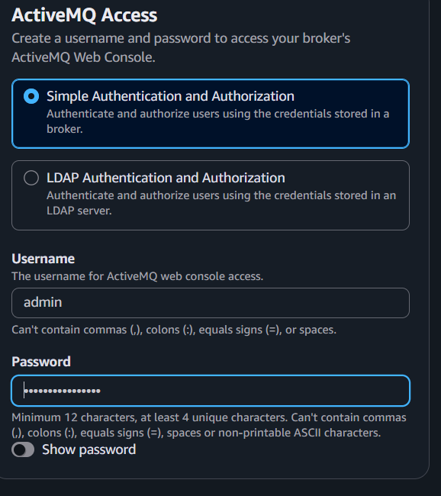

Step 4: Network Settings
Select
Your VPC
Choose
One subnet
Choose
Default Security Group
Public Access
Enabled (for lab)
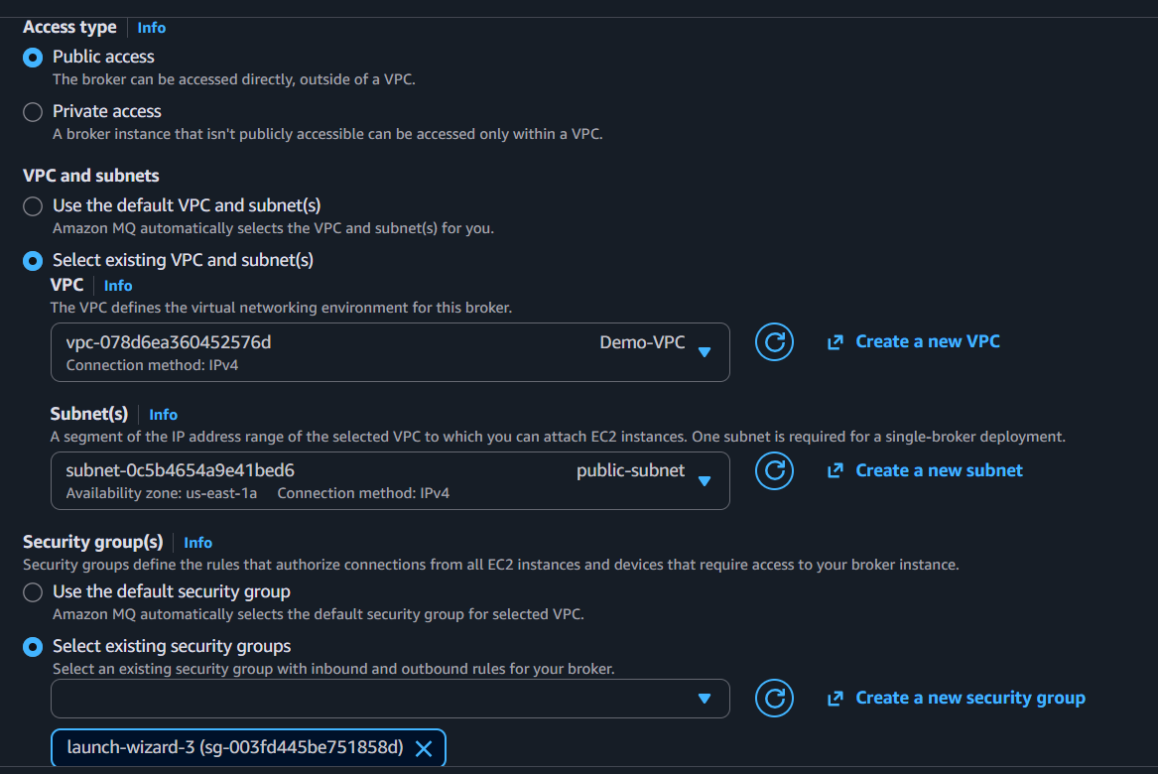

Step 5: Storage
Use
General Purpose (gp3)
Leave defaults.

Step 6: Create Broker
Click
Create Broker
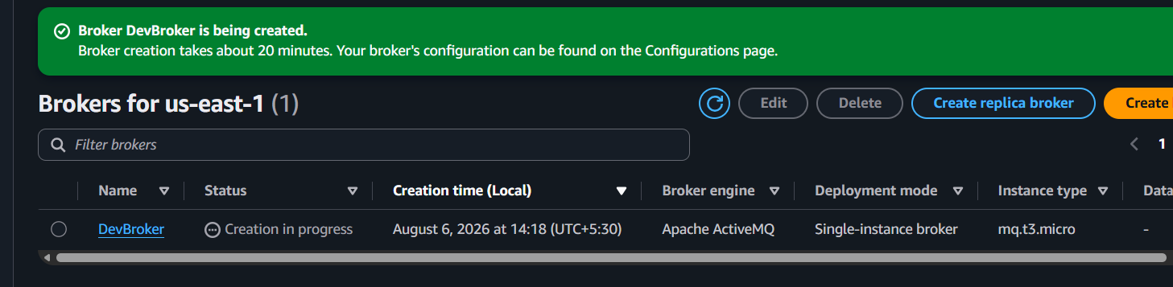
Wait Approximately 15–30 minutes
Status
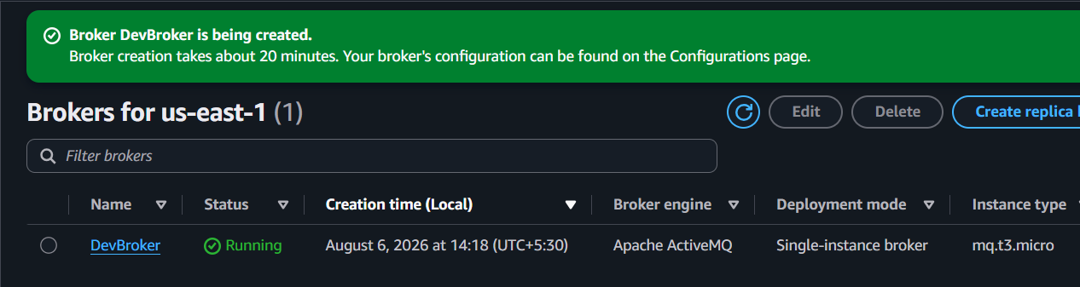
Running

Step 7: View Broker Details
Observe
- Broker ID
- ARN
- Endpoint
- ActiveMQ Web Console URL
- Engine Version
Record these details.
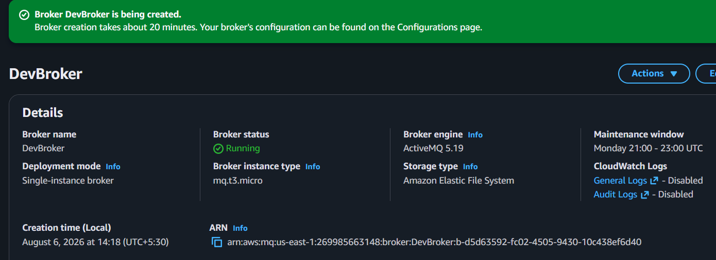
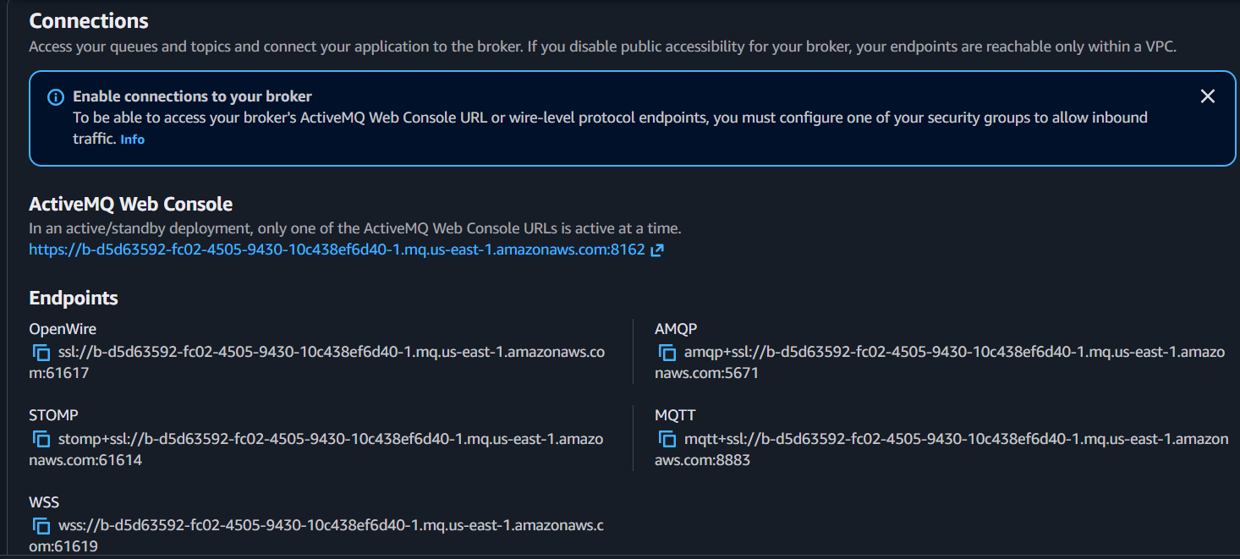

Step 8: Open ActiveMQ Web Console
Copy the Web Console URL from the broker details.
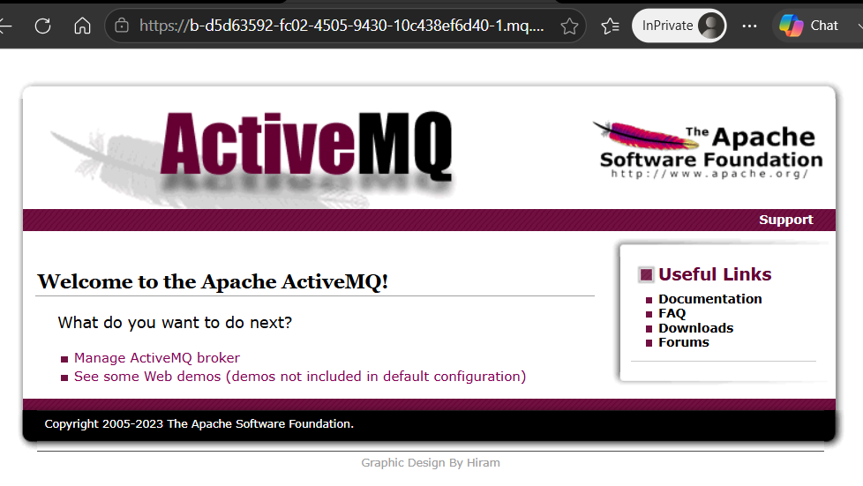
Log in using the username and password created earlier.
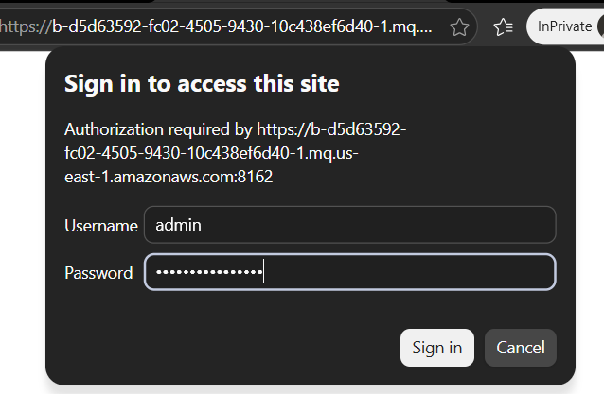

Step 9: Create Queue
In the ActiveMQ Web Console
Create a queue named
Orders
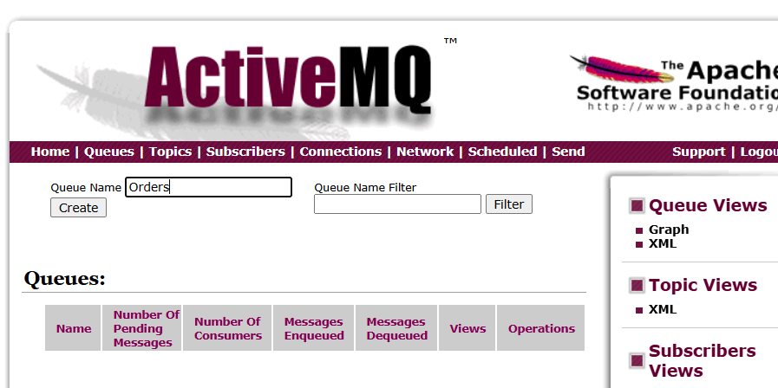

Step 10: Send Messages
Publish messages such as
Order 101

Order 102

Order 103
Verify that they appear in the queue.
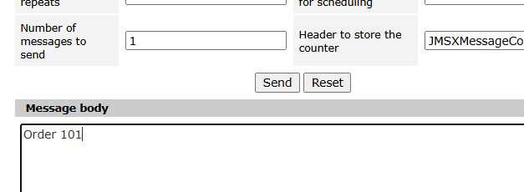

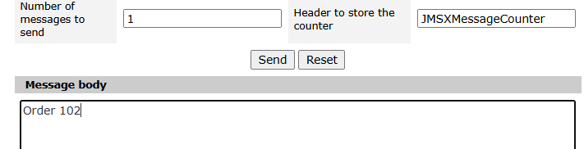

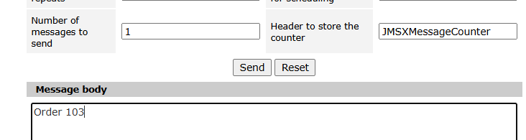

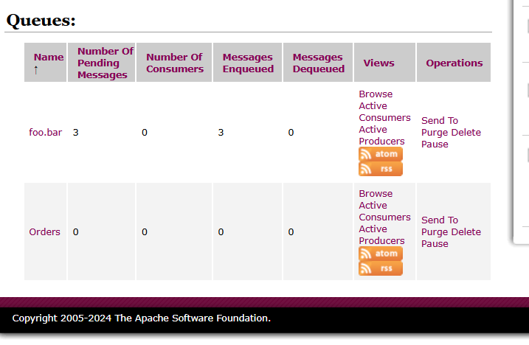

Step 11: Consume Messages
Use the ActiveMQ Web Console to browse or consume messages from the Orders queue.
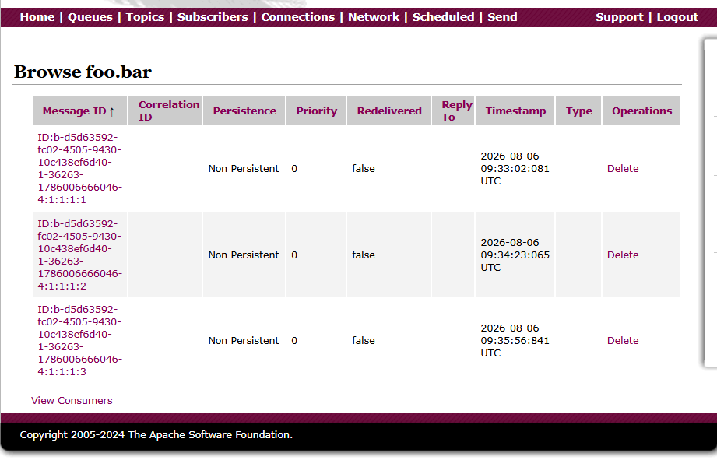
Confirm that messages are removed after successful consumption (depending on the chosen operation).
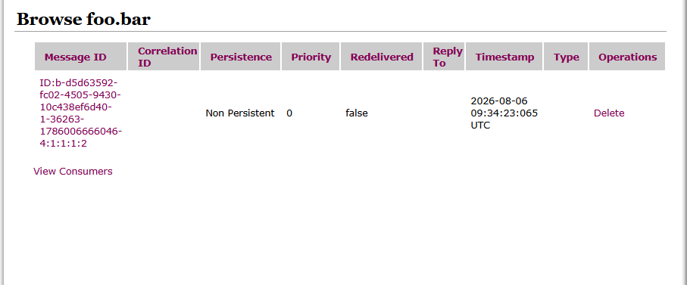
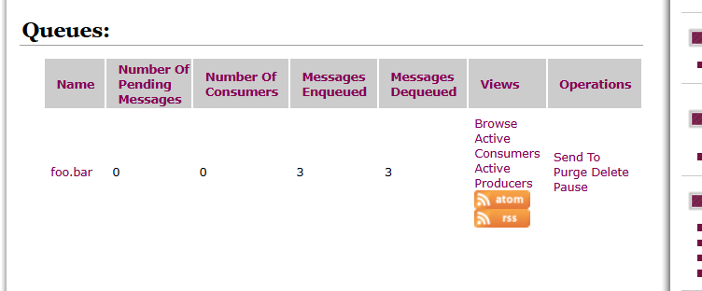

Step 12: Monitor Broker
Open
CloudWatch → Metrics → Amazon MQ
Observe metrics such as:
- Current Connections
- Enqueue Count
- Dequeue Count
- Memory Usage
- CPU Utilization
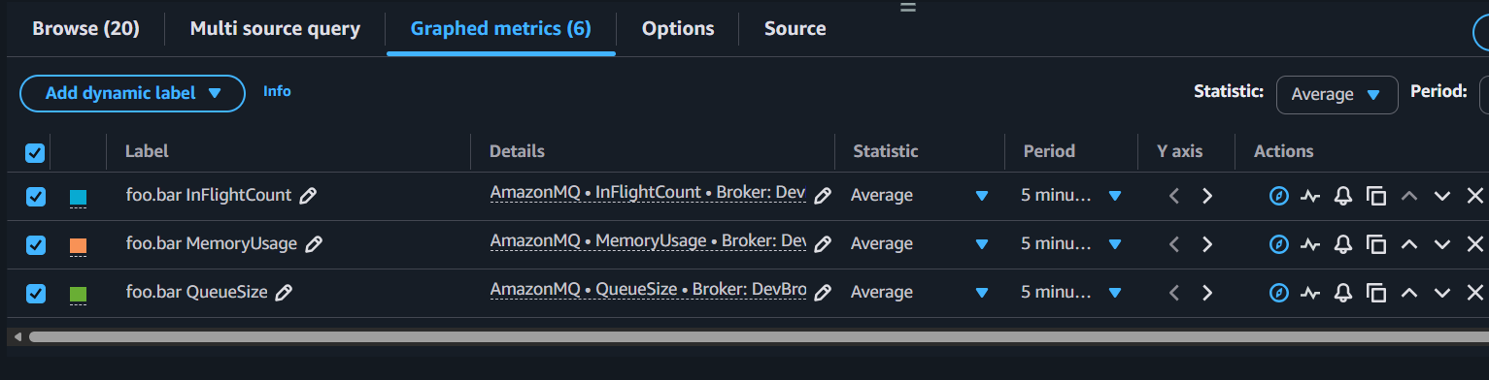
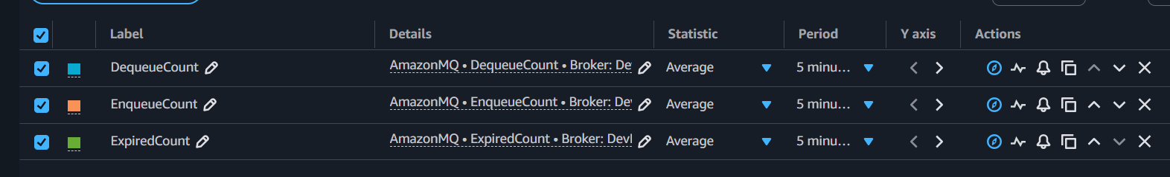

Observations for Amazon MQ
- Amazon MQ provides a managed message broker.
- ActiveMQ supports standard messaging protocols such as JMS, AMQP, MQTT, STOMP, and OpenWire.
- Queues persist across broker restarts when using persistent messaging.
- CloudWatch provides broker health and performance metrics.
- Broker creation takes significantly longer than SQS because infrastructure must be provisioned.

Implementation Document (Amazon MQ)

Architecture
Application A → Amazon MQ Broker → Application B

Configuration Steps
- Created an ActiveMQ broker.
- Configured administrator credentials.
- Selected VPC and subnet.
- Created the broker.
- Accessed the ActiveMQ Web Console.
- Created a queue.
- Sent and received messages.
- Verified CloudWatch metrics.
- Tested broker persistence (optional).
- Deleted resources after testing.

Result
Successfully deployed an Amazon MQ broker, created a queue, exchanged messages, and monitored broker health using CloudWatch

